**CSci 543: Advanced Artificial Intelligence October 3rd, 2017**

**Due: 24:00 PM, October 15th (Sun.) 2017 Instructor: Dr. M. E. Kim**

**Assignment 2: Temporal Probabilistic Reasoning – DBN & HMM (150 points)**

**Instruction:**

For each question,

1. Define the variables and their values: e.g.) C = Cancer - a Boolean Random Variable (R.V), T = Test –a domain of T = { +, – } for a positive result or for a negative result, respectively, etc.
2. Define the given probabilities with the variables and the values: e.g.) P(c ) = 0.5
3. Define what probability is asked to compute in the question: e.g.) P(-|c) – a probability that a patient had a negative test result though a patient has a cancer.
4. Show a proper steps of computation with the formulas to get the final solution.

e.g.) P(A | B) = P(A, B)/P(B) = P(B|A)P(A)/ P(B) = 0.3 * 0.5 / 0.8 = 1/6.

Do NOT simply describe your computations verbally without the proper definitions of probabilities.

If you program it,

1. Run your program to get the answer.
2. Capture the screen image of your answer.
3. Insert the image to the corresponding question in the HW file.

Any solution neither with the proper formulas nor with the computational steps will get **no** point.

You should work on the assignment***, independently***. – Any plagiarism or collaboration is **not** allowed. – Refer to the syllabus and Code of Student Life.

<http://und.edu/student-affairs/code-of-student-life/_files/codepdfs/appendix/iiia/iiia-3.pdf>

**Submission:**

1. Prepare your homework using a word processor, a MS Word: no **.pdf** ﬁle is acceptable.
2. Write your name in the homework.
3. Name your ﬁle in the format**, HW2-YourLastName.docx**: e.g.) HW2-Kim.docx
4. If you have files of source codes, (a) create a directory being named as ‘HW2-YourLastName’, (b) locate every file including the HW file in the directory and (c) compress the directory to .zip file.
5. Upload your HW file or the compressed .zip directory in the blackboard system.

**Q1. [20 + Optional] Temporal Reasoning in BN**

We examine what happens to the probabilities in the umbrella world in the limit of long time sequences. Use the Bayesian Network structure and conditional distributions in Fig.15.2.

1. [10] Suppose we observe an unending sequence of days on which the umbrella appears.

Show that, as the days go by, the probability of rain on the current day increases monotonically towards a fixed point (i.e. it converges to a fixed value). Calculate this fixed point.

1. [10 + Optional] Now consider forecasting further and further into the future, given just the first two umbrella

(U1, U2) observations.

1. [10, Optional] Compute the probability *P(R2+k|U1, U2)* for *k*=1, …, 20, and see that the probability converges towards a fixed point. You can write a program to compute it.
2. [10] Calculate the exact value of this fixed point.

Note: In general, when any *P(Rk)* converges to a fixed point *c*,

*. ∀ n∈N, $\lim_{n→∞}{P(Rn)}= \lim_{n→∞}{P(Rn-1)}=c$*

**Q2. [10] Variable Elimination in DBN**

Consider applying the variable elimination algorithm to the umbrella DBN unrolled for 3 slices, where the query is **P**(*R3* | *U1, U2, U3* ). Show that the complexity of the algorithm – the size of the largest factor – is the same, regardless of whether the rain variables are eliminated in forward or backward order. For the probability of transition model and that of sensor model, refer to Fig. 15.1.

**Q3. [60] DBN and HMM models in Temporal Reasoning**

A professor wants to know if students are getting enough sleep.

Each day, the professor observes whether the students sleep in class, and whether they have red eyes.

The professor has the following domain theory:

* The prior probability of getting enough sleep, with no observations, is 0.7.
* The probability of getting enough sleep on night t is 0.7 given that the student got enough sleep the previous night; otherwise, 0.3.
* The probability of having red eyes is 0.2 if the student got enough sleep; otherwise, 0.7.
* The probability of sleeping in class is 0.1 if the student got enough sleep; otherwise, 0.3.

1. [10] Formulate this information as a **dynamic Bayesian Network (DBN)** that the professor could use to filter or predict from a sequence of observations.

NOTE: Drawing a DBN of your model is a part of the formulation.

1. [30] For the evidence values below, perform the following inference.

**e1** = not red eyes, not sleeping in class

**e2** = red eyes, not sleeping in class

**e3** = red eyes, sleeping in class

1. [10] State estimation: Compute P(*EnpoughSleep*t | **e1:t**) for each of *t*=1, 2, 3.
2. [10] Smoothing: Compute P(*EnpoughSleep*t | **e1:3**) for each of *t*=1, 2, 3.
3. [10] Compare the filtered and smoothed probabilities in A and B for *t*=1 and *t*=2.
4. [10] Suppose that a particular student show up with red eyes and sleeps in class every day.

Given the model above, explain why the probability that the student had enough sleep the previous night converges to a fixed point rather than continuing to go down as we gather more days of evidence. What is the fixed point? Answer it both numerically and analytically.

1. [10] Formulate the problem as a **Hidden Markov Model** that has only a single observation variable.

You should draw a HMM and give the complete (conditional) probability distribution for the model in its Transition matrix and in its Sensor matrix.

**Q4.** [30] Robot Sensing Problem

Robot is in the world with 3 locations A, B, C.

The probability that the Robot is in one of location is: P(A) = P(B) = P(C ) = 1/3.

The color of location A is Red while the colors of location B and C are Green.

Robot has a sensor to detect a color, but the sensor is unreliable. The probability that it senses the color of location correct is only 0.9 for each location.

P(Red | A) = P(Green | B) = P(Green | C) = 0.9

Robot is seeing Red currently.

1. [10] What is the probability that the Robot is in location A?
2. [10] What is the probability that it is in location B?
3. [10] What is the probability that the Robot is in C?

**Q5. [**30**]** MCMC

Consider the query *P(Rain|Sprinkler = false, WetGrass=true)* in Figure and how MCMC can answer it.

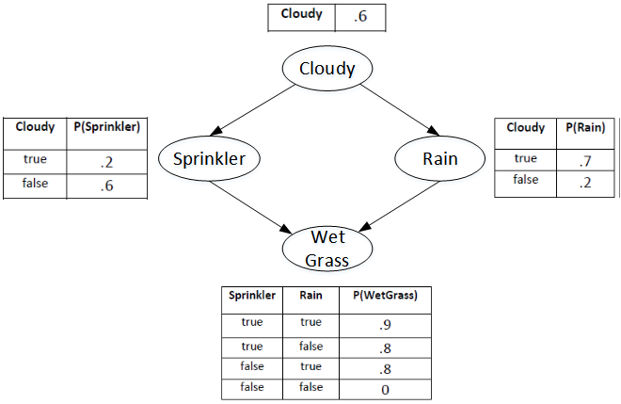

1. [5] How many states does the Markov chain have?
2. [25] Calculate the transition matrix **Q** containing ***q(y → y’)*** for all *y, y’*.

First of all, compute the sampling distribution for each variable, conditioned on its Markov blanket.

* 1. [2] *P(C|r, s)*
  2. [2] *P(C|¬r, s)*
  3. [2] *P(R|c, s,w)*
  4. [2] *P(R|¬c, s,w)*
  5. [17] Using the above probabilities, compute Q below.

|  |  |  |  |  |
| --- | --- | --- | --- | --- |
| ***Q*** | *(c, r)* | *(c, ¬r)* | *(¬c, r)* | *(¬c, ¬r)* |
| *(c, r)* |  |  |  |  |
| *(c,¬r)* |  |  |  |  |
| *(¬c, r)* |  |  |  |  |
| *(¬c, ¬r)* |  |  |  |  |